How to Play the Nintendo TCG
Rule version 1.0
By Pete Grigsby

1 – Introduction:
Hello! My name is Pete, and this is my card game. I have loved Nintendo mostly all of my life, my very first game was Startropics at about the age of 2 or 3. Ever since my parents bought an NES I have been a die hard Nintendo fan. When it comes to me, I always love making new games or ideas. I also have played competitive card games a lot of my life, the main one being pokemon. I hope you enjoy this game as much as I had fun making it!
So how did this game all start? Well back around 2006/2007 I wanted to make some type of card game, I noticed Nintendo really never made a competitive card game besides pokemon. And I thought it would be fun. To be honest, I started making cards on MS paint, but that took so long and proved to be inconsistent. Then I moved to a website where I could make them really fast (but the game was vastly un-balanced, illogical to their game counter parts, and contained many typos) after years and years of testing with friends I feel I finally have a definitive version that I have consistently worked with (formula wise) for the Nintendo TCG!!
Without further ado, let’s step right in and learn!!!

2 – Where to start:
The first thing to do is Download Set-1 Beginning Battles at http://nintendostorm.synthasite.com/nintendo-tcg-sets.php
Future sets will be released so feel free to download those as well! Always make sure to check this site, my twitter @SPIRE_FAN, or my youtube channel at http://www.youtube.com/user/saurfan
For this section we will be using Mike Jones as an example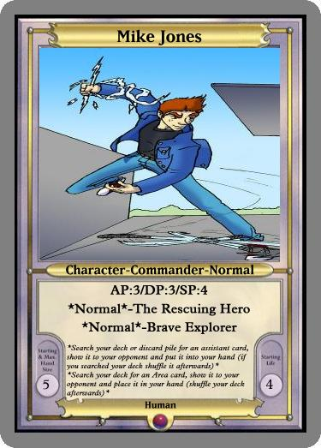
This game uses 40 card decks to play with the max of 3 multiples per card in a deck. The only 1 card that is required in a deck is a Commander just like Mike Jones here. At the start of the game, you choose 1 commander in your deck and lay them face down in front. Then you and your opponent shuffle your decks and offer to cut them (always offer to cut after you shuffle, cutting is letting your opponent take a section of the deck above or below and placing it on top or below the deck. The opponent can also shuffle if desired). After that each player draws 5 cards.
One player then flips a coin or rolls a dice and asks the opponent to “call it” meaning the opponent claims either heads or tails. If the call is correct, that player goes first.
3 – Material’s
Before we jump into the first turn and how every card works, I want to cover the materials needed to play this game.
Dice: You will need to make sure you have at least 10 small dice, these are used to keep track of damage, and hand power. The dice used for rolling must be clear and cut on the edges.
Sleeves and Carbacks: Since these cards will most likely be printed as thin paper, you will need card sleeves so that you can’t see through the back of the card. I highly recommend Ultra Pro or Magic sleeves. They are made with strong quality and very cheap. (http://www.trollandtoad.com/p303326.html)
As for cardbacks, these are cards to put behind your paper cards in the sleeve. It’s to make the sleeve strong and sturdy. Make sure all card backs look the same on the back (like all pokemon cards, all magic cards, etc.) For example, I use 40 pokemon cards for 1 deck, the cards I use are generally the ones I don’t play with in competitive pokemon. If you need help purchasing card backs, buy a pokemon starter deck and use 40 of those cards as card backs (you also get a mat and a coin) (http://www.trollandtoad.com/p325723.html)
A Coin: This game will use coin flips every now and then, you can use a 6 sided dice instead of coin, with heads being even and odds as tails
Printing your deck: Once you download the sets and build a deck, I recommend making a folder and placing your card copies into it. Then highlight those cards and print. Make sure when you print that you print them in a size that can fit in the card sleeves (there should be a 3 by 3 wallet size option that prints 9 cards per page). If you want to print off the entire set or just really high quality cards, I recommend printing in bulk at an office depot. They print High Quality pictures for an extremely cheap price.

4 – Character’s
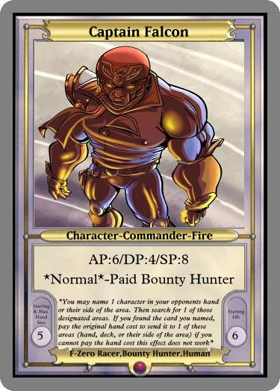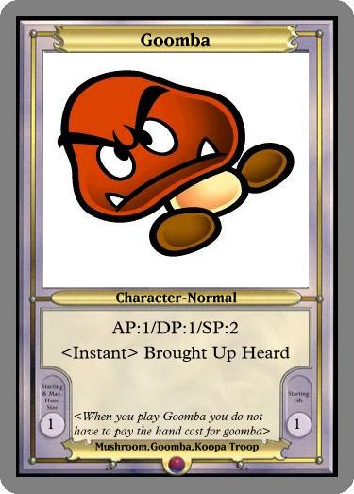
The first thing to do is explain all the things on a card.
Name of the card: (Captain Falcon) this of course help’s know what the card is. You can only run 3 multiples of cards with the exact same name in a deck.
Character: The main card type of the game. You use characters to do battle and help you win. Characters go into battle and are all very unique.
- Character-Commander: These are the main leader’s of your deck. Before the start of your game you choose 1 commander from your deck and place them face down on your side. (you must still pay hand cost for your starting commander, if you can’t when the game starts, the commander is shuffled in and you start with none)You can only have 1 Commander out on your side at a time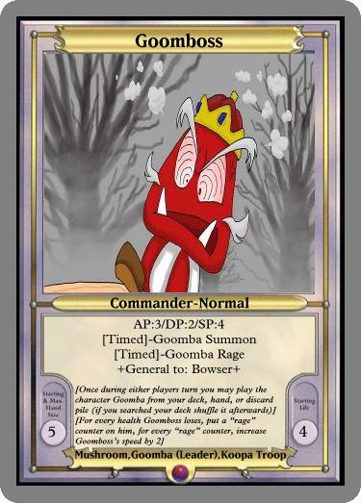
- Character-Commader’s that have +General to: (Name of Commander)+
These type of commader’s can be played or stay out if the name of the character they are a general to (like bowser) is played or is out before hand. Example: I have Bowser out, who is a commander, but because Goomboss is a general to bowser, I can play goomboss while Bowser is out, despite the commander rule. (hand cost is still applied)
If you look at the very end of a character, you will notice an element (or two). This element helps describe more of the character. The nine Elements are: Fire, Water, Air, Lightning, Ice, Forest, Earth, Shadow, and Normal
Right below the type are the stats for a character AP (Attack Power) DP (Defense Power) SP (Speed Power) and HP (Health Points) health is located at the bottom right while the other 3 are located at the top. These stats are mainly applied at the battle phase, which is at the end of a player’s turn.
When a character takes Damage by effect, it goes straight to the character’s HP. If a character’s HP hits zero, they are destroyed and sent to the discard pile.
On the bottom left you will notice a number. This number is called the hand cost. When you play a character from your hand or any card with a number at the bottom left, you must pay the hand cost number from your total hand power. If you play a card by another method (effect, etc.) you only have to pay if it say’s
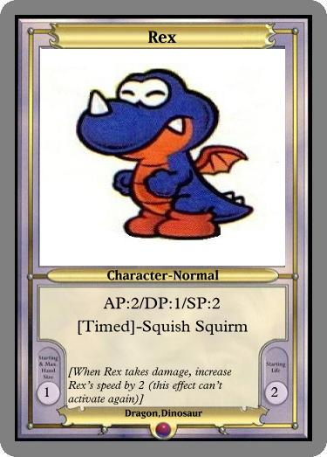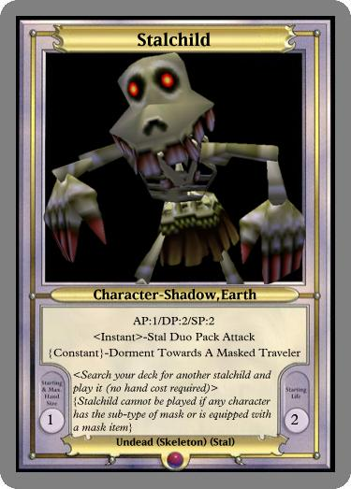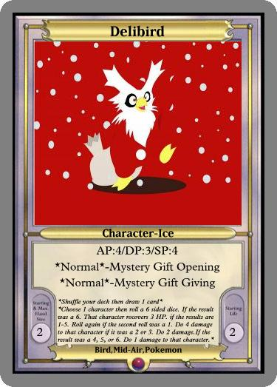
Right below the stats are a character’s effects. There are 4 different type of effects, each with unique borders. Below the effects names are the effect descriptions ordered top to bottom.
The 4 type of effect are
*Normal*- These effects are the standard effects in the game. Each normal effect can be used once per your turn, unless that character is Tapped.
[Timed]- These effects can only be used under certain times or situations (on either player’s turn).
<Instant>- These effects activate right when the character is played and cannot be activated at any other time. You do not have to activate the effect if you wish
{Constant}- This effect is always on. 24/7
*Attack* - This is the same as normal effects except it counts as an attack so the character is tapped afterwards

Sub-Type’s: This isn’t just for character’s but if you look at most cards, at the very bottom you can see different words that describe a card (like on Delibird it say’s Bird,Mid-Air,Pokemon) This a way to help categorize a card a lot better. Sometimes a card will say “Search your deck for a card with the sub-type of pirate and put it into your hand” So obviously you would search for a card with Pirate listed in its sub type.
But if the effect “Search your deck for a card with a sub-type of pirate LISTED ANYWHERE on the card and put it into your hand” you could search for any card that just simply listed pirate anywhere in the sub-type names, like - Space Pirate or Land Pirate. Not just Pirate
5 – Assistant’s
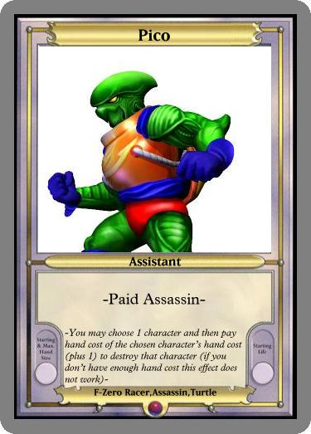
Assistant’s are very strong cards, you can only play 1 Assistant once on your turn. The Assistant stays out until the end of your turn.

6 – Area’s
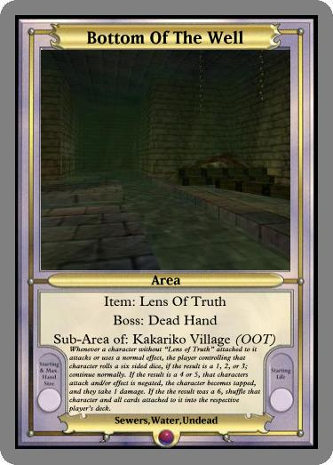

An Area card is what it say’s; it affects the entire play area (both you and your opponent’s side). Only one Area can be played at a time, if a new area is played, discard the current one.
The effect of the Area card affect’s and can be used by both sides (unless it say’s otherwise).
Below the type are the listings for the area. Like the Item, Boss, and sometimes what it is a cub-area to.
Sub-Area: A sub-area is a small section on the play area. For example, Bottom of the Well say’s it is a sub-area of Kakariko Village (OOT). So if the area card Kakariko Village is played, Bottom of the well becomes the sub-area to it (or you can play Bottom of the Well if Kakariko Village is out because it is a sub-area). During a player’s turn, a player may choose to move characters or play cards in the sub-area or out of it.
So for example, if I choose to move Captain Falcon to a sub-area (this counts as a movement), he can only be targeted and affected by other cards in that sub-area. So if my opponent’s staryu tries to damage captain falcon via effect, but Staryu is in the main area not the sub-area it won’t work. Staryu would have to be played in the same sub-area as Captain Falcon.
If a Sub-Area is destroyed or sent somewhere out of the play area, all cards in that Sub-Area go to the same destination
Think of the Area and Sub-Area’s as different places. If Vulcain uses the effect to do 2 damage to all character’s, it would only affect the one’s placed in the same area as vulcain.
Character’s that are tapped cannot make movements

7 – Placement
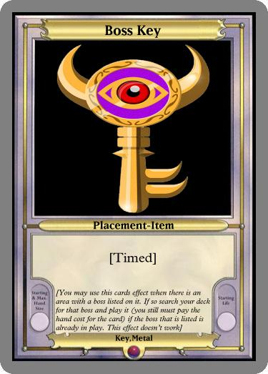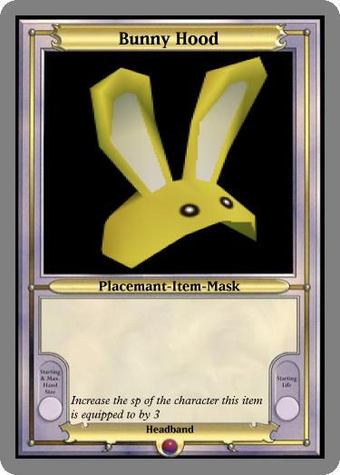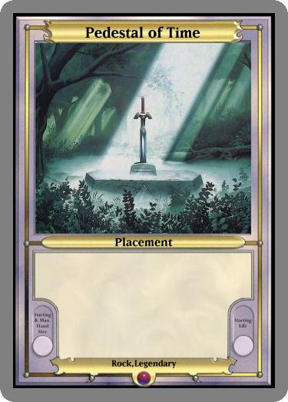

Placement card’s what they are. You just place them down. Now just like other cards, Placements have more specific types
Items: Items are used to attach to a character (after they are played). They have effects a lot like character’s
*Attack* - A character can use the effect of the item. If so, they’re tapped right after it.
<Instant> - Right when the item is attached, the effect is activated and the item is discarded
[Timed] – The Item can only work at certain times
(Constant effect’s are like the normal effects listed. So they don’t have constant as a type)

Masks: A mask is a specific Item, only 1 mask can be on a character at a time

8 – Effect Cards
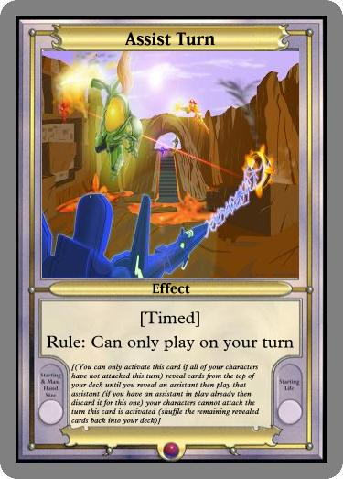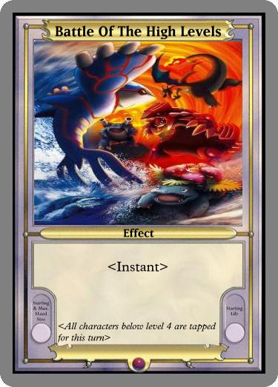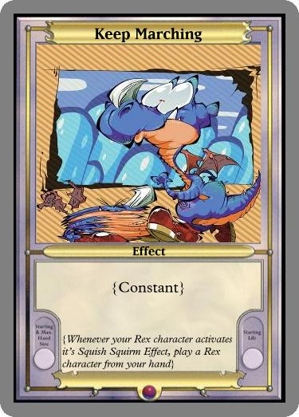

Effect cards are fast and easy play down cards that can change the flow of the game. The different type of effect cards are. You can only play effect cards on your turn except for timed effects

[Timed] – These cards stay in your hand and can only be played at certain times. You can play these effect cards down on your opponent’s turn if the requirements are met.
<Instant> - These cards are played down and instantly activate
{Constant} – These cards stay out once they are played
*Attack* - Attach the effect’s to your character right when they activate, the character can use this effect card. If so, the character is tapped

9 – Required/Tokens
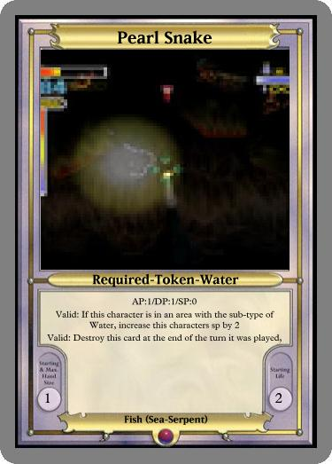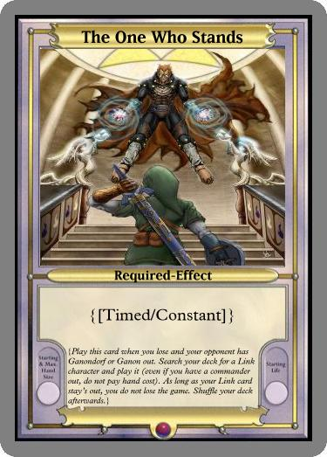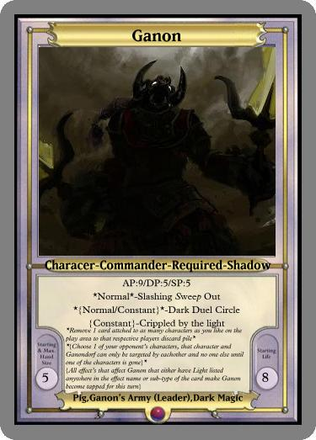

Required cards are vastly unique. They are placed in your extra deck; which is an unlimited amount of required cards placed in a pile on your side.
Every required card needs a certain requirement to be played. Either the actual required card or some other card will always tell you how or when you can play that card. When that card leaves the play area, place it back into your extra deck.
Tokens represent lower leveled characters that are generally played from level 5’s. Tokens CANNOT use effects of any sort. Just like required cards, once they leave the play area, they return to the extra deck. Tokens do not require hand power to play (you don’t play any hand cost at anytime to play tokens).
The multiples of tokens out might sometimes become so much that it would be best to have a pile of cards from another game and use those as the tokens, with 1 reference.

Well that’s the run down of all the different type of cards. Now let’s get into playing the game!!

10 – Battle Phase
At the end of a player’s turn, the battle phase will ALWAYS conduct (but you can choose for character to not attack). This is where the stats of characters truly shine. Not that the battle phase does not conduct on the very first turn of the game. Let’s have an example battle. Here Is what is on player A’s side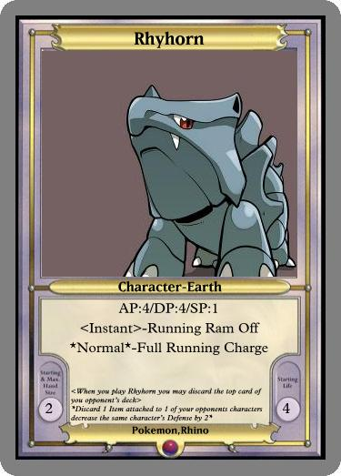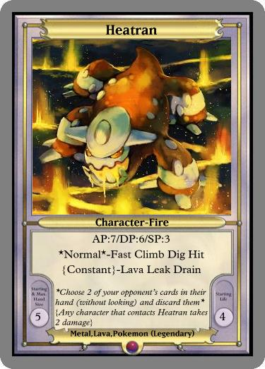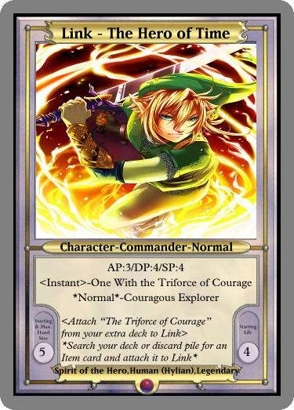

And Player B’s side:
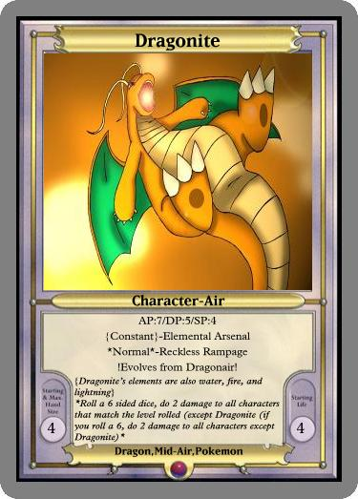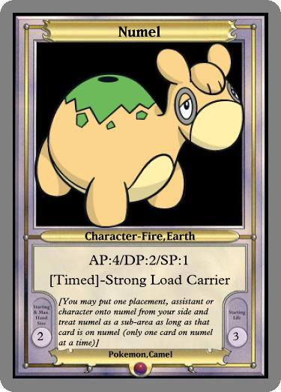

Please make sure to use dice and place them on a character representing how HP they have lost (a five for five damage, etc.)
Player A is the one ending his turn, so before the turn ends, the battle phase will be conducted and Player A will have speed priority if his fastest character matches the speed of one of his opponenents. The first thing to conduct in the battle phase is SP. As we can see Player A’s Link has the same SP as his opponent’s Dragonite and Mike Jones (with 4 SP being the highest on the board at the moment). So with the speed priority rule applied (read first sentence), the order of who attacks is; Link -> Dragonite and Mike Jones (in any order) -> Heatran -> Rhyhorn -> Numel
So Link attacks first; he attacks Numel, Numel’s DP is depleted to Zero, and loses 1 HP. Link is then tapped (cannot attack, make movements or use normal effects).
Dragonite then attacks Link, Link now has 1 remaining HP and his DP is depleted to Zero. Dragonite is then tapped
Mike Jones attacks Link, who’s DP is already depleted to Zero, so the attack goes straight to Links HP. Link is now destroyed and Mike Jones is now tapped
Heatran attacks Dragonite, depleting Dragonites DP to Zero and doing 2 damage to Dragonite. Heatran’s Constant Effect “Lava Leak Drain” comes into play, and it does 2 damage to Dragonite. Destroying Dragonite. Heatran is then tapped
Rhyhorn attacks Numel and destroys it. Rhyhorn is now tapped

A character’s DP goes back to normal right after the battle phase (but if a character’s DP has been depleted via effect, for example if Dragonite was his by Rhyhorns “Full Running Charge” his DP would be depleted to 3 permanently, so once dragonite un-taps, it’s DP goes back to 3, not 5) Now any effect between turns happens, Player A and B increase their hand power by 2 (representing a turn has passed) and all characters are un-tapped (unless an effect keeps them tapped longer).
11 –Turn Priority via Effects
If during player A’s turn (example), player B activates a timed effect, or some type of effect (besides constant) that he or she is allowed to do, since it is player A’s turn, he gets one reply before the effect activates.
So basically, everytime someone activates a non constant effect, and it’s not that player’s turn, the player who’s turn it is get’s to do 1 action (activate effect, play a card, etc.) before the effect is resolved.
12 –Vitality Points
Vitality Points or VP are the actual players Vitality. If their Vitality hits Zero, they lose. If a player has no more character’s, then any character that attacks from the opponent goes straight to the players vitality points. So if the opponent had 2 Goomba’s (AP of 1) and a Dialga (AP of 8) and the other player has no characters. When the opponents characters attack, they go straight to the player (1 + 1 + 8 = 10 = Gameover).
Another way to win is if the opponent cannot draw a card at the start of their turn
-These are the two main ways to win the game, but some cards might give players more ways to win. 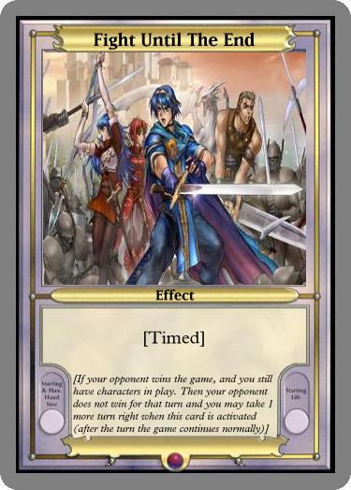
Never give up!
13 – The Example Game
Mario and Luigi will be playing the example game. Mario is playing a Goomba deck, while Luigi is playing a Link Deck. They made sure their decks contain 40 cards each and at least 1 commander
*First both player’s choose a commander from their deck and face them down, Mario chooses Goomboss and Luigi chooses Link. They must take into concept of the 5 hand power they both start with at the beginning of the game.
*Both players then shuffle their decks and offer to cut (splitting/stacking half of the deck on top of the other)
*Mario flips a coin and say’s “call it!” Luigi say’s “heads”. The coin lands on heads, Luigi will be going first. Both of the Mario Bros then flip over their commander’s. Both Goomboss and Link are level 5 so they both pay the 5 hand power they start with via hand cost. Luigi uses Link’s instant effect and attaches triforce of courage from his extra deck to Link
*Luigi and Mario increase their hand power by 2 at the start of every turn, with both now being at 2 Luigi draws his card.
*Luigi play’s down Samurai Goroh (his assistant). He pay’s zero hand cost to search for a level 1. He shows Mario his search was for Rex, then he shuffles his deck and offers Mario to cut or shuffle. Luigi pay’s 1 hand cost and play’s Rex down. Mario then uses Goomboss’s “Goomba Summon” Effect, since it is Luigi’s turn he gets one action before Mario’s effect resolves (view section 11). So Luigi desides to play down the placement Assist Trophy, now Mario searches for a goomba and play’s it. Mario shuffles his deck, and Luigi’s turn continues.
*Luigi uses Link’s Normal Effect and searches his deck for an Item Card. He shows Mario he searched for Focus Sash, Luigi then attaches it to Link and shuffles his deck, offering to cut after (by now, it’s well shown that everytime a player shuffles, they offer the opponent to cut or shuffle it themselves).
*Luigi passes, no battle phase is conducted due to it being the first turn of the game.
*Mario and Lugi increase their hand power by 2. Mario is now at 4 and Luigi at 3
*Mario Draws, Mario pay’s 3 hand cost to play Kingdra down. Mario uses Goomboss’s Effect and searches his deck for a goomba and play’s it down. Mario now ends his turn.
*Before Mario’s turn is ended, the battle phase conducts. Here are the character’s on each side.
Mario: 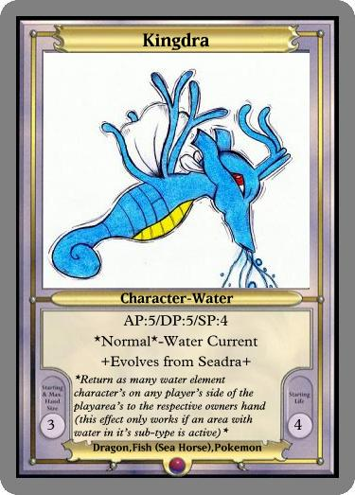
Luigi: with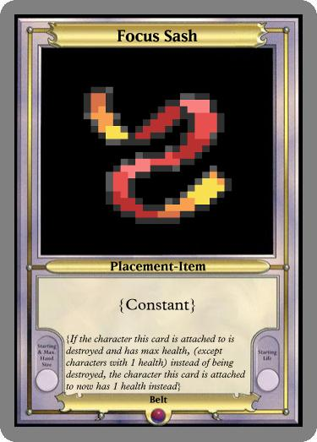
Mario goes first due to turn priority, Goomboss Attacks Rex, Rex is destroyed
Link Attacks a Goomba, Goomba is destroyed
Kingdra Attacks Link, Link’s DP is at zero and he lost 1 HP
Goomba Attack’s Link, Link loses another HP
*The turn ends, all characters are untapped and the DP’s are reset to default (Link’s is back to 4, etc.) And both player’s gain 2 more hand power (Luigi at 5, Mario at 3)
*Luigi Draws, uses Link’s Effect and attaches Assist Trophy, it instantly activates, Luigi reveals until he gets Dr. Stewart, he pays 1 to play Rex.
*Mario uses Goomba Summon, Luigi has no reply. Luigi now ends his turn, but before that happens, the battle phase is conducted.
(The same amount of characters are on both sides, but Link only has 2 hp)
Link attacks Goomba, Goomba is destroyed
Goomboss attacks Rex, Rex is destroyed
Kingdra and Goomba attack Link, Link is destroyed.
*Character’s are untapped and both hand powers go up by 2.
*Mario draws and ends his turn, Luigi has no characters so all the attacks from Mario’s character’s go straight to Luigi’s Vitality points. Luigi loses all 10.
Mario Wins

14 –The Glossary
Terms that are useful to look up and understand if you have a question
Reveal: Usually refers to showing your opponent cards from the top of your deck or hand to the opponent. Most of the time it is only temporary.
Tap: Making a character Tapped. Usually before the battle phase (the character usually stays tapped)
Active: The card is out on the play area
Discard Pile: The section in front of the deck where destroyed cards go
Removed Area: A section placed to the right of the discard where cards are removed from the game
Hand Power: The “energy” of the game. Each player starts with 5 hand power in a game (though usually all of it is spent once players reveal their commanders because most of them take 5 to play) Both players get 2 hand power in between turns.
Hand Cost: The amount of hand power you pay to play a card, activate an effect, etc. The amount of hand cost you pay for a character is always located to the bottom left of a card
Status: Sometimes a card or the play area will be affected by a status. Right next to the status name it usually tells you what happens to the target while in the status
Instrument: A type of Item card, Instrument’s are used to play Song Cards
Song: Generally a type of Effect card, Always equip a song to a character. But a character can only activate a song if they have an instrument attached to them. A character may play 1 song per turn (only on their turn). Playing a song does not count as a movement
Movement: Whenever a character Attacks, uses a normal effect, of moves to another area.
Negate: Cancelling the activation of something. Like if Player A played an effect card that said “draw a card” and Player B countered by playing a timed effect that say’s “When an effect card activates that let’s a player draw a card or cards, negate it.”. Player A’s card effect does not work and is destroyed
AP: Attack Power, sometimes called Attack in some effects. When a character attacks normally (not by effect) their AP is applied.
DP: Defense Power, sometimes called Defense in some effects. Defense is used to shield damage done to a character’s HP. A character’s defense is reset to normal at the end of the turn (stat reduction and increases by effect still apply). When a character attacks another, that characters AP is subtracted from the defending characters DP. All leftover AP after deduction goes to the defending character’s HP
SP: Speed Power, sometimes called Speed in some effects. Speed determines who goes first in the battle phase. The character with the highest Speed always attacks first. (The effects of Turn Priority still apply)
HP: Health Points, sometimes called Health in some effects. In the game, when a character’s Defense is Zero, and they get attacked, they take damage directly to their HP. Use dice to keep track of damage on a character
VP: Vitality Points, the main life that each card player has in a game (10 at the start) if a player has no characters, when a player’s character is allowed to attack, the attack goes straight to their opponents vitality points. If a players Vitality Points hit Zero, they lose.
Reduce (stat): When a stat is reduced, un-less it say’s otherwise, the stat is reduced permanently.
Turn Priority: Who ever’s turn it is always has turn priority. Turn Priority is used usually when stale mate situation occur, like if both players have characters with with matching SP during the Battle Phase. If Player A has a character with an SP 8 and so does Player B. But it’s Player A’s turn, Player A’s character is allowed to attack first, or if Player A has 3 character’s with an SP of 2 and Player B has 1 with the SP of 2. All of Player A’s 3 SP character’s may attack first
Attack Pass: When a player chooses not to attack with a character
Mask: A specific Item card, only 1 mask can be on a character at a time
Commander: These are the main leader’s of your deck. Before the start of your game you choose 1 commander from your deck and place them face down on your side. (you must still pay hand cost for your starting commander, if you can’t when the game starts, the commander is shuffled in and you start with none)
Damage by effect: When a character takes Damage by effect, it goes straight to the character’s HP.
Play Area: The place where all cards are played
Sub –Area: A small section on the play area. For example, Bottom of the Well say’s it is a sub-area of Kakariko Village (OOT). So if the area card Kakariko Village is played, Bottom of the well becomes the sub-area to it (or you can play Bottom of the Well if Kakariko Village is out because it is a sub-area). During a player’s turn, a player may choose to move characters or play cards in the sub-area or out of it. Character’s and cards in a sub-area can only be targeted and affected by cards in that sub-area. If a Sub-Area is destroyed or sent somewhere out of the play area, all cards in that Sub-Area go to the same destination

